General bed bug rearing conditions
Supplementary protocol to: Changes in body size and fertility due to artificial and natural feeding of laboratory bed bugs (Cimex lectularius)

Markéta Sasínková¹, Jana Křemenová², Petr Chajma¹, Tomáš Bartonička², Christian Massino³, Oliver Otti⁴, Ondřej Balvín¹

1 Department of Ecology, Faculty of Environmental Sciences, Czech University of Life Sciences Prague, Kamýcká 129, 165 21, Prague 6, Czech Republic
2 Department of Botany and Zoology, Faculty of Science, Masaryk University, Kotlářská 2, 611 37 Brno, Czech Republic
3 Applied Zoology, Department of Biology, Technische Universität Dresden, 01062 Dresden, Germany
4 Animal Population Ecology, Animal Ecology I, University of Bayreuth, Universitätsstrasse 30, 95440 Bayreuth, Germany

Housing
We keep our bed bug colonies in two different types of vials. Larger colonies are kept in 50 ml Falcon type tubes, with the bottom replaced with a mesh (Fig. 1). These vials are sufficient for colonies of around 100 adults and a few hundred of larvae. The surface area of the mesh may not be sufficient for such numbers of bed bugs to feed within the 30-minute interval on a blood bag, and feeding must be repeated to feed the entire population. Nevertheless, colonies up to 200 individuals are fed during that interval with no problems.
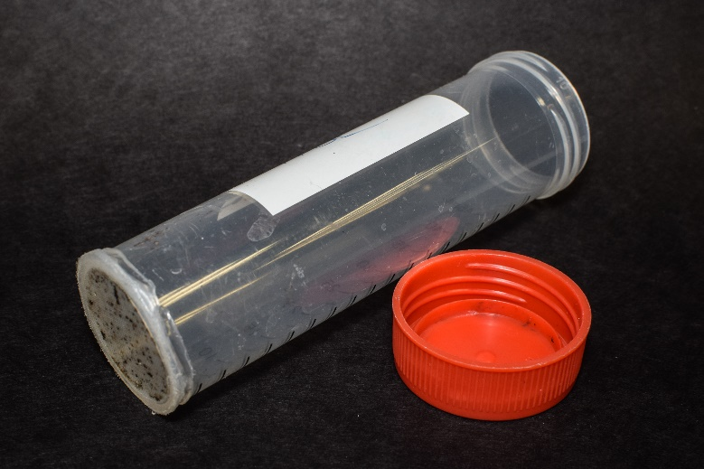 | 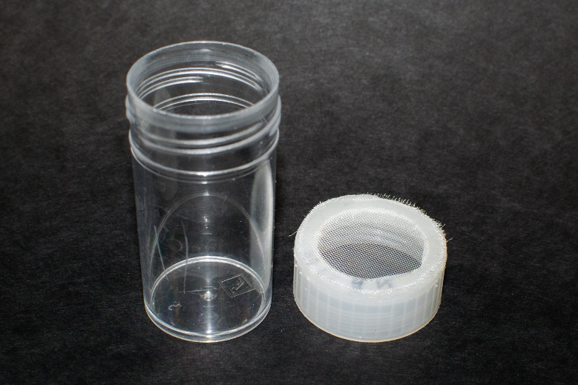
Figs. 1–2. Rearing vials made from 50 ml falcon tubes (Fig. 1, left), and from 15 ml sample vials (Fig. 2, right).
For smaller colonies, when raising controlled cohorts or housing and observing experimental individuals, we use 15 ml tubes with the mesh placed in the lid (Fig. 2). These tubes, when left standing on the bottom and equipped with a single plain piece of paper, prevent the bed bugs from residing on the mesh, forcing them to stay only on the paper, allowing us, for example, to count eggs easily. However, a majority of larger long-term colonies eventually occupy the lid as well. As bed bugs are difficult to remove from the mesh-equipped lid, vials with mesh at the bottom are much safer for manipulation with large colonies with respect to escaping. We use a high-quality industrial polyamide mesh (3 meshes per 1 mm; in CZ sold under the brand Uhelon, e.g., to beekeepers).
In contrast to most researchers, we keep the bed bugs on small strips of paper with no fold. The paper strips are cut 1 to 2 millimeters narrower than is the inner diameter of the vial. Due to this, when two or more of such paper pieces are placed in the vial, they remain close together, creating tight spaces suitable for bed bug refugia. The reason for using non-folded paper is again to prevent the bed bugs from escaping during manipulation. Folded paper needs to be opened by forceps, and if they slip, energy accumulated in the fold readily ejects the bed bugs from the working dish.
The vials with bed bug colonies are kept in ventilated plastic boxes. The inner edges of the box are conditioned by a mixture of vaseline and paraffin to prevent the bed bugs from escaping. A saturated solution of kitchen salt maintains the humidity inside the boxes at 70%. The boxes are kept at 27 °C (regularly checked by data loggers) and 12:12 light regime in a rearing chamber (approximately 1 m³ but can be smaller) with a passive ventilation through a light-blocking fabric. The setup includes only a thermostat, a timer, a heat cable, and a fluorescent lamp (4000 K). Plug-in devices needed for such a setup should cost under €200. However, our chambers are bricked, and the thermostat and the timer are firmly installed prior to the sockets where the cable and light are plugged in. Choosing the power output of the heat cable with respect to the size of the chamber and the temperature in the surrounding room will prevent overheating to lethal levels in the event of a thermostat failure. Therefore, such a setup is not only much cheaper but also safer with respect to accidental overheating than commercial climate chambers. Still, we included a back-up thermostat into our installation to avoid accidental violation of conditions during experiments. Using LED light would further minimize the risk of overheating; however, low-power LED lights with full spectrum are difficult to acquire.
The light regime in the rearing chambers is inverted to the natural circadian cycle, allowing the bed bugs to be fed in the dark during the environmental day period. Feeding sessions are carried out in total darkness. When we conduct experiments focused on circadian rhythms, the bed bugs are manipulated only in red light (LED with singular wavelength) during their night period. Under red light, only adults are safe to be handled with forceps. Sorting colonies, working with eggs or larvae, or preparing virgin individuals is therefore done in the day period. For other assays, we do not avoid an occasional disturbance by light.
Artificial feeding
Human blood conserved by CPDA can be purchased from transfusion clinics, depending on local regulations. However, according to our experience, not every facility will sell it for scientific purposes, with respect to the administration setup or ethical stand. For example, we asked five entitled facilities in Prague, Czech Republic, and only one offered to sell blood in CPD, but not CPDA. We were then able to buy CPDA-conserved blood only at the Faculty Hospital in Brno. However, for this study, we used CPDA-conditioned collection tubes (Vacuette), so we had collected the blood from volunteers (performed by trained personnel). There are several advantages of collection tubes over collection bags. First, the bags contain 63 ml of CPDA solution for the collection of 450 ml of blood, while tubes with a final volume of 9 ml contain only 0.7 ml of the solution. The dilution of blood by the preservative is therefore nearly half in the tubes compared to the bags. Second, most transfusion clinics (at least in the Czech Republic) use only 450 ml bags. With regard to the expiration period of the blood, large quantities of bed bugs would have to be reared to make use of all the blood. One 9 ml vial will feed 10–15 medium-sized bed bug colonies of around 50 adults and an appropriate number of larvae, which we keep in 50 ml tubes. Third, manipulation with the tubes is easier as since the content is usually all spent in one feeding session, there is a lower risk of contamination.
Blood bag construction from Parafilm M was inspired by Aak and Rukke (2014). A parafilm piece of a size of 10 x 5 cm is folded in half and stretched to the sides, perpendicular to the direction of the fold. To prevent the vials from being soaked in water from the water bath, empty edges are made on all sides of the bag by pressing the two parafilm layers together with fingers (Figs. 3, 4). This way, the blood-filled area (Fig. 5) is just the right size for two vials can cover and make use of most of it (Fig. 7). The volume of blood needed to fill the bags depends on the size of this area and is adjusted to reach approximately 2 mm blood layer. After most of the blood is consumed, the bag can be rolled in half to raise the blood level. This way, it can hold one vial. However, bed bugs are able to feed from the very last drops of blood, emptying the bag until only a few red spots remain. This way, we achieve nearly zero waste of the blood. However, as this poses a risk of bed bugs being left partially unfed, we always feed the experimental colonies and individuals from full bags, and emptier bags are fed to stock colonies.
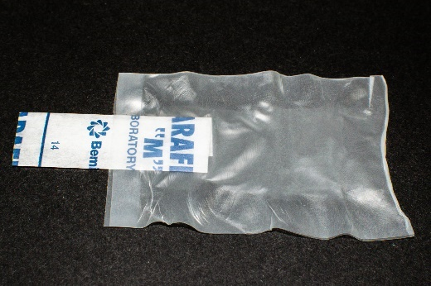 | 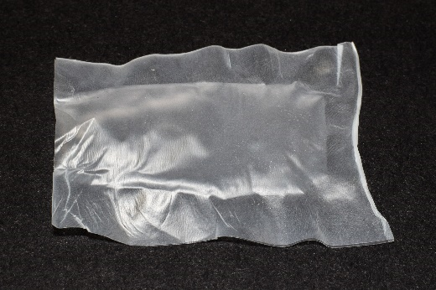 | 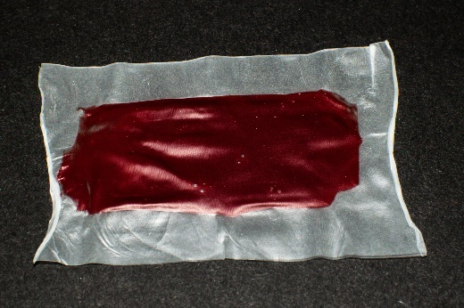
Figs. 3–5. Parafilm bag in the phase of pressing sides (Fig. 3, left): one end is kept open by insertion of a folded piece of paper. The open end is cut across the folded paper and opened by breathing in (Fig. 4, middle), and filled with blood and closed (Fig. 5, right).
According to our experience, any manipulation with blood must be as sterile as possible to avoid contamination before feeding it to bed bugs. Even if the blood is fresh during feeding, it stays in the body of the bed bug for long enough for bacteria (e.g., Serratia) to proliferate and kill the bed bug. Therefore, all manipulation with blood is done using sterile syringes and needles. Touching the inner surface of the parafilm bags by hands is avoided during bag manufacturing. In case any blood is left in the parafilm bags, the bags are not stored for the next feeding session. The recommended storage time for CPDA-conserved blood in the collection tube is 5 weeks; we use blood for a maximum of 4 weeks from collection.
Blood bags are heated on a wet tissue laid over an aluminum plate, placed in a water bath surface (Fig. 6). If put directly on the aluminum, the bags tend to stick. We set the temperature of the water bath by placing a thermometer inside a tester parafilm bag filled with water. We reach the desired 37 °C (Bell and Schaefer 1966) in the bag by setting the bath at 40 °C, but this offset can vary according to the bath construction. An economical and reliable version of a water bath can be easily built from a polystyrene cool box, a thermostat, a heat cable, and an aluminum plate, which covers most, but not all, of the water surface. As the water evaporates, the thicker the plate, the longer the water stays in contact with the plate, heating it. Feeding should take place at room temperature to allow for a temperature gradient within the tubes to attract the bed bugs to the blood bags.
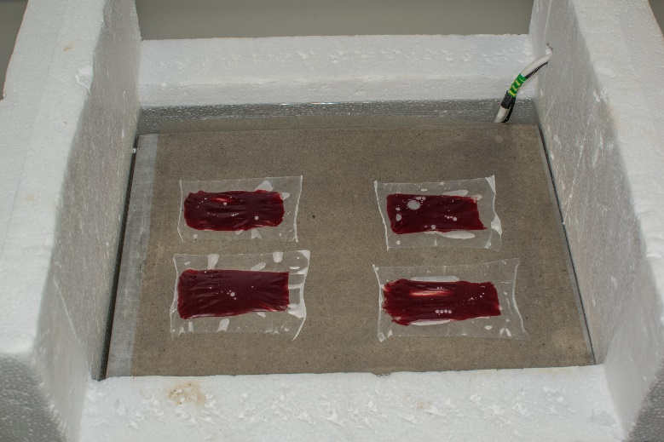 | 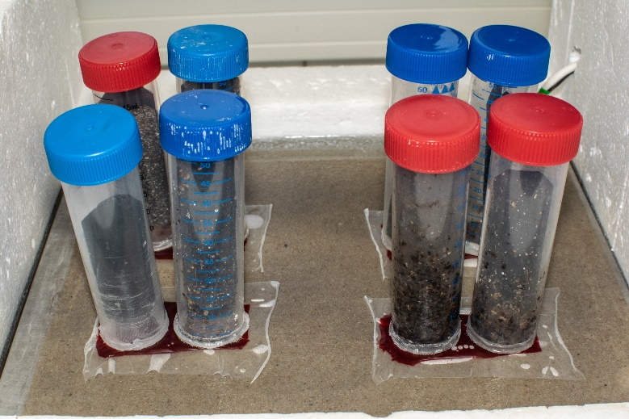
Figs. 6–7. Blood bags heated on an aluminum plate, lined with a paper towel, in an in-house made water bath (Fig. 6, left), fed to bed bug colonies (Fig. 7, right).
We let each population feed for 25–30 minutes (Fig. 7). Then the blood bag is removed and tilted from side to side to prevent sedimentation of the blood. In adapted colonies with managed numbers, nearly 100% of the bed bugs will feed within this period.
If a population is well-adapted to laboratory rearing, a one-week period at 27 °C is sufficient for all larval stages to molt into the next stage. A weekly feeding regime is therefore nearly optimal for maximum population reproduction. Also, within a week, the female lays nearly 80% of the eggs she can lay after a single feeding (78.8% on average in the bed bugs tested in this study). Within the week, close to none of the eggs hatches. When separating generations, removing unhatched eggs from the population and letting them hatch separately is much easier than separating hatched first instar larvae from older bed bugs. Two weeks after feeding the female, (majority of) first instars separated this way are hatched and ready to feed.
Feeding on human volunteers
The bed bugs to be fed on human volunteers are kept in 15 ml tubes with the mesh in the lid. To allow hands to be free for other work, the bed bugs are fed on the volunteer’s thighs, attaching the tubes with a nylon stocking. The thigh is covered by a dark cloth to prevent too much light.
Feeding on bats
In each feeding session, a special cylinder tube containing one bat and a group of bed bugs is placed in the dark for 20 min. Before handling, the bed bugs are counted to make sure all of them will be collected after the feeding. To create a refuge for them, a piece of dressing gauze is placed under the lid after the bed bugs are introduced into the feeding tube. After the feeding period, the bat is removed from the tube and carefully examined, especially its wing membranes, ears, and uropatagium. The bugs that are still present on the bat’s body are carefully removed with soft entomological tweezers. However, there is usually only a minimum of the bed bugs remaining on the bat's body; most of them are concealed in the coiled gauze. This procedure has proven to be useful, especially in the case of handling small nymphs after feeding, which can easily lead to their damage when using soft tweezers. Permanently handicapped bats of large European species (Myotis myotis and Nyctalus noctula), which would have perished without human help, were used. Due to regular manipulation, such individuals easily adjust to handling and they did not appear to be stressed when being parasitized by a reasonable amount of bed bugs.
References
Aak, A., and B. A. Rukke. 2014. Bed bugs, their blood sources and life history parameters: a comparison of artificial and natural feeding: Artificial feeding of bed bugs. Med. Vet. Entomol. 28: 50–59.
Bell, W., and C. W. Schaefer. 1966. Longevity and Egg Production of Female Bed Bugs, Cimex lectularius, Fed Various Blood Fractions and Other Substances. Ann. Entomol. Soc. Am. 59: 53–56.

